Draft Terms of Reference
GEO Land Degradation Neutrality (LDN) Initiative
To be adopted on 02 November 2018

Note: These Terms of Reference (ToR) serve as an Addendum to the GEO LDN Implementation Plan, as submitted to the Group on Earth Observations (GEO) and approved by the GEO Programme Board on 14 June 2018. Both the Implementation Plan and the ToR will be reviewed on an annual basis by the GEO LDN Steering Committee, and updates will be submitted to GEO for approval as necessary. The procedure for making amendments to the ToR is described in Section 3.1 of this document.

- Vision and Mission of the GEO LDN Initiative

Vision: National and local actors in all countries use Earth observation (EO) to achieve land degradation neutrality (LDN).
Mission: The GEO LDN Initiative will promote the collaborative development, and support the provision and use, of EO datasets, quality standards, analytical tools and capacity building to avoid, reduce, and reverse land degradation with the aim of achieving LDN in all countries by 2030 (SDG 15.3). The Initiative will help connect data providers to data users, including researchers, decision-makers, land use planners, commercial sector, donors/investors and other stakeholders in order to optimize the use of EO datasets for LDN assessment, planning, implementation, monitoring and reporting.

- Overview of the Structural Elements of GEO LDN Initiative

The organizational structure of GEO LDN Initiative is reflected in the figure below.

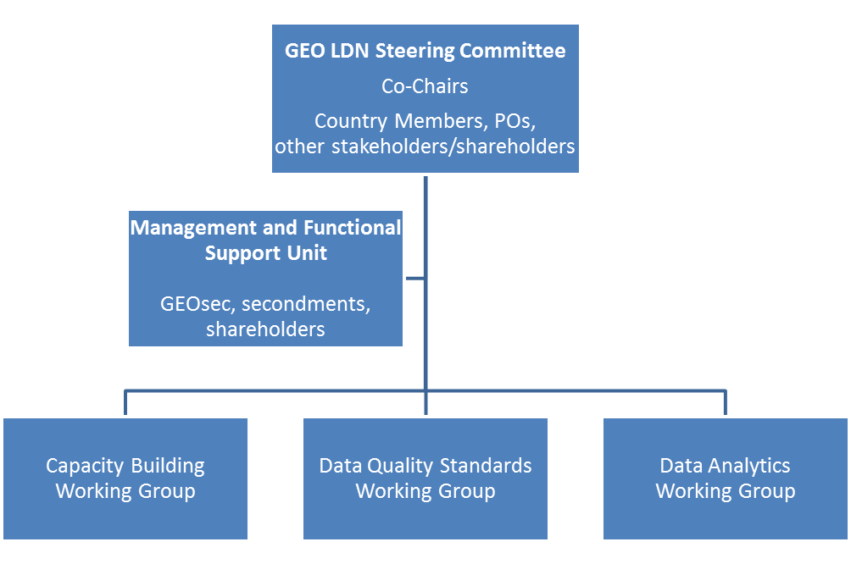

The structural elements of the GEO LDN Initiative include:

- Steering Committee: The main decision-making body, responsible for providing strategic direction and coordinating GEO LDN Initiative activities, identifying and, where possible, contributing resources.

- Management and Functional Support Unit: The unit responsible for managing the daily operations and logistical support for the Steering Committee and its activities, and providing scientific and technical coordination for the activities of the working groups.

- Working Groups: Responsible for implementing specific project activities in support of the GEO LDN Initiative’s main objectives.

- Details of the Structure of the GEO LDN Initiative

This section provides information about the roles and responsibilities and modus operandi for each structural element. Participation in the Steering Committee and Working Groups will not be remunerated. Attendance at Steering Committee and Working Group meetings will generally be funded by the members themselves, although opportunities for travel funding will be sought by the Steering Committee, particularly for members from developing countries. Efforts will also be made to schedule meetings back-to-back with relevant meeting and events.
  - Steering Committee

The Steering Committee is the main decision-making body, responsible for coordinating GEO LDN Initiative activities. The responsibilities and duties of the Steering Committee are to:

- Provide oversight and strategic direction for the GEO LDN Initiative;
- Promote the aims and objectives of GEO LDN Initiative and expand its profile and prominence;
- Review and endorse the Implementation Plan and Annual Work Plans of the GEO LDN Initiative;
- Monitor and evaluate institutional effectiveness of the GEO LDN Initiative against aims and objectives outlined in the Implementation and Annual Work Plans;
- Conduct user needs assessment and represent stakeholder interests to the greatest extent possible;
- Provide guidance and support to the GEO LDN Initiative Working Groups and monitor their progress;
- Coordinate the production of deliverables for reporting to the GEO Secretariat;
- Work with the Management and Functional Support Unit to identify new stakeholders that would contribute to and benefit from the GEO LDN Initiative;
- Identify opportunities for collaboration between and among stakeholders;
- Facilitate and coordinate relevant activities and mobilize resources when opportunities arise.

The Steering Committee will, as far as possible, operate by consensus. Decisions requiring a vote will be decided by simple majority of the votes cast. The quorum for a valid vote is participation of one half of the voting members of the Steering Committee. Votes may be held at meetings or by appropriate electronic means. These procedures will apply, for example, to make any changes to the ToR. The Steering Committee will meet in person at least once yearly and via teleconference on a monthly basis.

The Steering Committee will consist of the country members, POs, leads (or Co-Leads) of Working Groups and other stakeholders and shareholders, if any. Shareholders, as defined here, are those organizations that contribute resources for the overall coordination of the GEO LDN Initiative (e.g., Management and Functional Support Unit, publications, meetings, events) and/or the production of new tools or services specifically branded as GEO LDN Initiative products. Stakeholders are those organizations that contribute to, or benefit from, the GEO LDN Initiative, and in particular the outputs of the Working Groups, either as a provider or end user. It is anticipated that between one-third and one-half of the Steering Committee will consist of representatives of user communities.

The total number of seats on the Steering Committee will be limited to 12. Members will be elected by the interim or existing Steering Committee, from among the nominations received following an open call. Nominations can be made by stakeholder and shareholder organizations, or members of the GEO community. Self-nominations will be welcome. In their decision, interim or existing Steering Committee members will take into account the contributions of the shareholder organisations being represented, the relevance of the stakeholder organisations being represented, the balance between “providers” and “users”, geographical and developing country representation as well as gender balance.

Steering Committee members will serve a 3-year term with the potential for two one-year extensions (not to exceed 5 years in total). The term may be shortened to two years, for example if a member is serving as a representative of another organization, to align with the term they will serve as official representative (e.g., Chair or Executive Committee member) of that organization. Three Co-Chairs will be elected by the Steering Committee members, and will serve terms of three years, with the potential for two one-year extensions (not to exceed 5 years in total). Exceptions to the 5 year limit are subject to approval by the Steering Committee.

  - Management and Functional Support Unit

The Management and Functional Support Unit is responsible for managing the day-to-day operations of the GEO LDN Initiative and ensuring that activities are kept on schedule. The Management and Functional Support Unit is composed of the GEO Secretariat, secondments and contributing shareholders/stakeholders. A small number of members-at-large (preferably no more than 3) may be appointed by the Steering Committee to fill gaps in geographical representation and/or expertise.

The Management and Functional Support Unit will operate via regular e-mail correspondence and conference calls will be held on average every two weeks. The Management and Functional Support Unit will also provide scientific and technical coordination for Working Groups as well as logistical support for GEO LDN Initiative activities. The Management and Functional Support Unit will report to the Steering Committee Co-chairs; its duties and responsibilities are to:

- Provide scientific and technical coordination for Working Groups;
- Provide day-to-day logistical support for the GEO LDN Initiative;
- Support the Steering Committee in the coordination of the GEO LDN Initiative deliverables;
- Promote the GEO LDN Initiative in the international arena;
- Report to the GEO Secretariat on behalf of the GEO LDN Initiative;
- Support the organisation of the GEO LDN Initiative meetings and events;
- Manage the GEO LDN Initiative communications.

  - Working Groups

Working Group leads are selected by the Steering Committee and responsible for recruiting members for their working groups. Membership in the working groups is open to all GEO members, POs, and other stakeholders and shareholders. The current working group titles are listed in the Implementation Plan. Additional working groups can be created according to Steering Committee voting protocols outlined in Section 3.1 of this document.

Working Group 1 – Capacity Building
Working Group 2 – Data Quality Standards
Working Group 3 – Data Analytics

The duties of the Working Group leads are to:

- Identify appropriate individuals to serve on working groups;
- Coordinate outputs from Working Group activities according to a work plan with a timeline for quantifiable and measurable deliverables;
- Contribute to other GEO LDN Initiative deliverables;
- Participate in reviewing GEO LDN Initiative activities and make contributions to the update of the Implementation Plan.

User Engagement
The working groups are expected to engage with end-users and stakeholders (e.g. NSOs) by appropriate means, such as surveys and dedicated workshops, to determine knowledge gaps and requirements in order to ensure development of appropriate products and linkages with relevant institutions.

The objectives and tasks of the respective working groups are outlined in the Annexes.

- Adoption and Review of the Terms of Reference

These Terms of Reference were adopted by the GEO LDN Initiative Steering Committee on 02 November 2018. This document will be reviewed on an annual basis by the Steering Committee.

Annex 1: Terms of Reference for the Capacity Building Working Group

- Objectives of the Capacity Building Working Group

The capacity building working group will focus on strategic objective 2 (Provide expertise, tools and training to build national capacities) and strategic activity 1 (Building capacity at the country and regional level ensuring national ownership of EO and in-situ measurements) contained in the Implementation Plan.

- Tasks of the Capacity Building Working Group

The three main tasks are:
- Increase the involvement of partner countries and other organizations.
- Develop innovative and fit-for-purpose training curricula and learning modules.
- Organize and implement of training on the use of available tools for accessing, processing, analyzing and interpreting data as well as validation techniques.

Activities under task (A) include:
- Identify partners countries and sub-regions for workshops, capacity building, trainings;
- Identify partners countries for data availability reviews including the ways and means to improve and increase in situ data collection; and
- Contact institutions and other organizations and GEO initiatives to identify and develop relevant collaboration opportunities.

Activities under task (B) include:
- Review and improve UNCCD and other capacity building materials for regional, national and sub-national deployment, including the Good Practice Guidance for SDG indicator 15.3.1;
- Further develop learning modules on the use of tools and data for (a) UNCCD and SDG reporting, (b) land use and spatial planning frameworks to implement measures to achieve LDN, and (c) other target systems and reporting obligations at national level to maximize synergies and avoid duplication of efforts; and
- Develop curricula and repository of information that can be tailored to the specific needs of partner countries.

Activities under task (C) include:
- Issue a call for proposals from GEO members and POs to host sub-regional capacity building workshops, in collaboration with National Statistical Offices (NSOs), specialized agencies and the “main reporting entity” for the UNCCD (focal points) and SDG reporting, to provide training on the use of available tools for accessing and interpreting data as well as validation techniques; and
- Collaborate with (sub) national agencies and actors that are planning and implementing measures to reach LDN.
Annex 2: Terms of Reference for the Data Quality Standards Working Group
- Objectives of the Data Quality Standards Working Group

The data quality standards working group will focus on strategic objective 3 (Assist with the further development of international standards and protocols for the indicator) and strategic activity 2 (Developing international standards and protocols) contained in the Implementation Plan.

- Tasks of the Data Quality Standards Working Group

The main task is:
- Develop minimum data quality standards and specifications (e.g., resolution, time series, classification systems) for the underlying methodology, data, algorithms, and tools needed for estimating SDG indicator 15.3.1 and its sub-indicators.

Activities include:
- Undertake a stock-taking review of existing data quality standards and initiatives (e.g., ISO standards) in line with the Quality Assurance for Earth Observation (QA4EO) initiative which has produced a number of guidelines that have been adopted as GEOSS ‘best practice’ documents;
- Organize a global consultation in 2019 to update the Good Practice Guidance for SDG indicator 15.3.1 including applicability to other relevant monitoring and reporting processes;
- Explore possible platforms (infrastructure encompassing both remote and in-situ) that would encourage a more harmonized approach to ensuring data quality standards and specifications, taking into account user requirements and potential for uptake at country level.

Annex 3: Terms of Reference for Data Analytics Working Group
1. Objectives of the Data Analytics Working Group
The data analytics working group will focus on strategic activity 2 (establishment of federated collaborative platforms with high computing capacities and big data analytics tools, e.g., EO data cubes) contained in the Implementation Plan.
2. Tasks of the Data Analytics Working Group
The main task is:
- Work towards establishing a federated collaborative platform with high computing capacities and big data analytics tools (e.g. data aggregators such as open source EO data cubes) using relevant OGC and ISO standards that would allow countries to easily select, access, process, analyse, interpret and quality control large EO datasets while at the same time ensuring national ownership.

Activities include:
- Review existing standards and interoperability issues on federated collaborative platforms;
- Develop fundable projects demonstrating use of EO in responding to LDN needs and challenges, aligned with LDN Vision, Mission and Implementation Plan (including algorithms, GUIs, etc., to guide and support country level decision-making and reporting, to achieve LDN). Projects should be well-defined with limited life-span and concrete deliverables (pre-operational global applications/services) involving local actors/institutions. Starting point could be 3 sub-indicators of SDG 15.3.1 (land cover, land productivity and carbon stocks).

Earth observation (EO) is the science of measurement of all aspects of the Earth system, including its physical, chemical and biological processes. Historically, the term has been applied mostly to satellite-based remote sensing, but modern usage encompasses a much broader field of observing systems, including low-level EO (from aircraft and unmanned aerial vehicles), in situ measurements and sampling campaigns. A key characteristic of EO data is that they are very commonly reused many times in different scientific studies and decision-making processes.
https://www.ncbi.nlm.nih.gov/pmc/articles/PMC3538291/
https://hydrology-tep.eo.esa.int
https://www.researchgate.net/publication/309491292_Big_Earth_Observation_Data_Analytics_Matching_Requirements_to_System_Architectures

